**Germanium**

*Space group*: Fd-3m, 227

*Lattice vectors*: *R*1 = (-*a*/2, 0, *a*/2); *R*2 = (0, *a*/2, *a*/2); *R*3 = (-*a*/2, *a*/2, 0)

*Atom positions*: Ge1 = (0, 0, 0); Ge2 = (*a*/4, *a*/4, *a*/4)

*Isotopes*: 20.38% 70Ge (69.924 amu); 27.31% 72Ge (71.922 amu); 7.76% 73Ge (72.923 amu); 36.72% 74Ge (73.921 amu); 7.83% 76Ge (75.921 amu)

*DFT*: Use VASP, QE, or both. PBEsol PAW, no *d* states in valence   
(QE: Ge.pbesol-n-kjpaw_psl.1.0.0.UPF; VASP: standard version with sol flag)

*Warning: DFT may give metallic. May need to check convergence with electronic smearing.*

**DFT:** VASP v5.4.4, PAW_PBE Ge 05Jan2001

**RTA:** ALAMODE v1.1.0

**Checklist** (*all data should be reported for the 2-atom primitive cell*)

***Structure***

* Converged relaxed ‘temperature (T)=0’ lattice constant *a* (target accuracy < 0.005 Å)

- Single value with 4 significant figures: 5.702Å

* Methods / convergence criteria
* Method: directly optimized by VASP with ISIF=3, test the convergence with respect to ENCUT, Kmesh, and SIGMA
* Energy/force thresholds: EDIFF=1E-8eV, EDIFFG=1E-7eV/Å

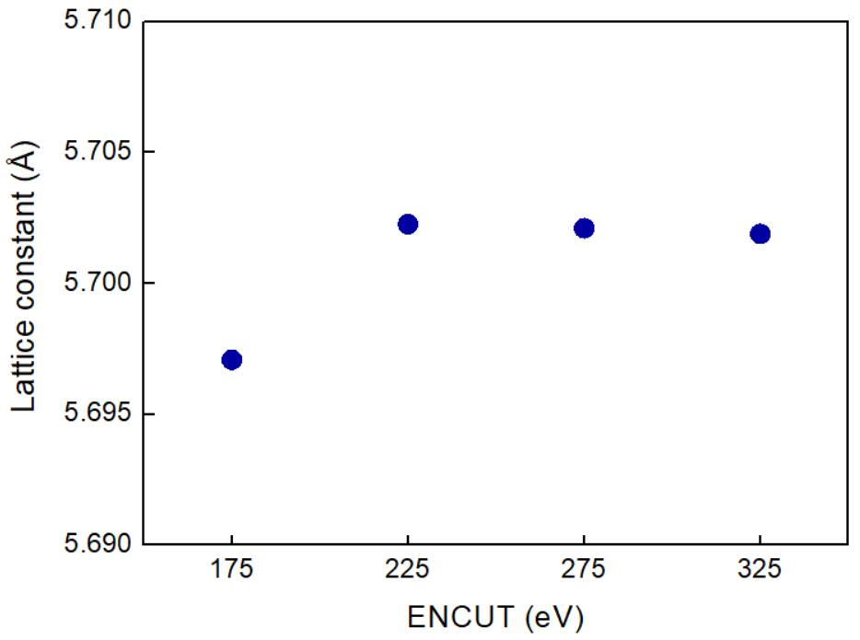

Fig 1. Lattice constant optimized with different ENCUT.

(DFT k-point grid=14x14x14, ISMEAR=0, SIGMA=0.03eV)

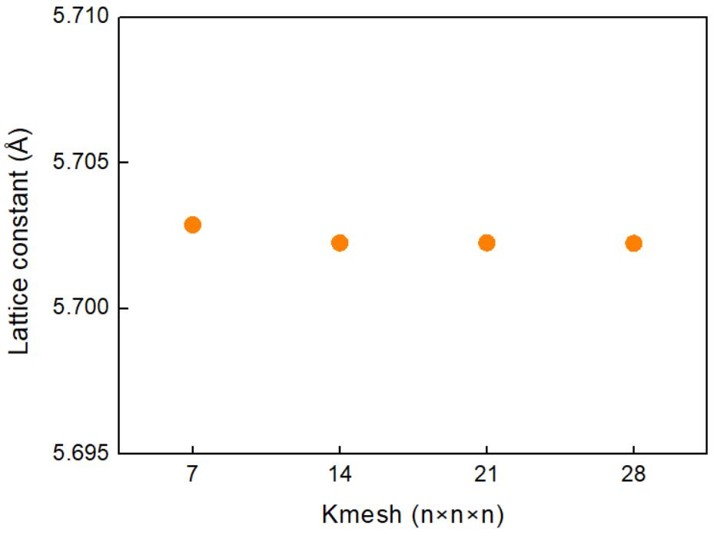

Fig 2. Lattice constant optimized with different DFT k-point grids.

(ENCUT=225eV, ISMEAR=0, SIGMA=0.03eV)

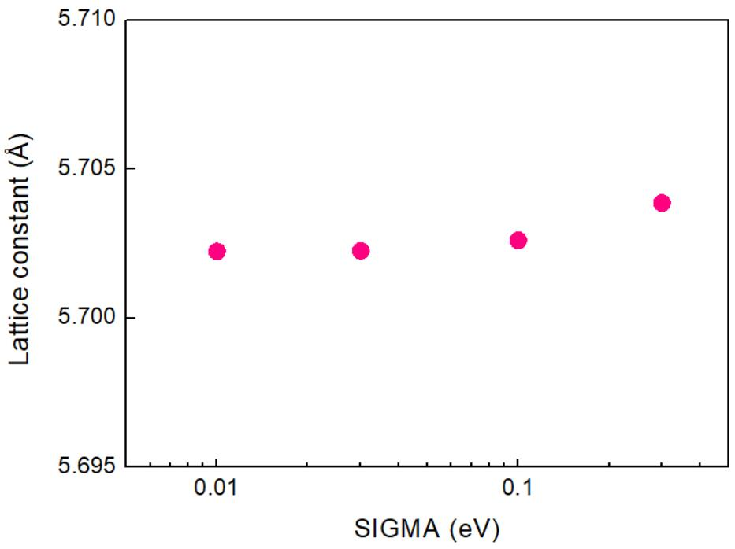

Fig 3. Lattice constant optimized with different SIGMA.

(ENCUT=225eV, DFT k-point grid=14x14x14, ISMEAR=0)

**Based on the above tests, the structure optimization was performed with ENCUT=225eV, DFT k-point grid=14x14x14, ISMEAR=0, and SIGMA=0.03eV.**

* Other notes / cpu hours (*e.g., multiple relaxations, compilers, hardware*)

Single relaxation

hardware: Intel Xeon Gold 6150, 18 core/CPU, 2 CPUs/node

5s running with 1 node

* All input files to run fully converged calculations (*e.g., qe.sc.in, POSCAR*)

Input files: POSCAR, INCAR, POTCAR, KPOINTS, run.sh

Location: Team Shiomi/Han Meng/01_Structure/Input files

***Electrons***

* Converged electron band dispersion (target accuracy < 0.1 eV for Γ/X/L frequencies)

- Numerical data: normalized wavevectors (q) and band energies (E): 4 valence bands and 6 conduction bands (excel or text file)

- q in units of 2π/*a* and f in eV

- 3 segments: Γ→X, Γ→K→X, and Γ→L evenly divided with ~100 q points per segment

- 3 files, one for each segment. For each scaled q from 0 to 1 list (~100 rows): q, E1, E2, E3, E4, E5, E6, E7, E8, E9, E10

File name: G-X.txt, G-K-X.txt, G-L.txt

Location: Team Shiomi/Han Meng/02_Electrons/Results

* Methods / convergence criteria

- Thresholds/ Integration mesh / grid shifting

EDIFF=1E-8, DFT k-point grid=14x14x14, grid shift=0 0 0

* Evidence of converged band structure

- Band structure with varying integration meshes

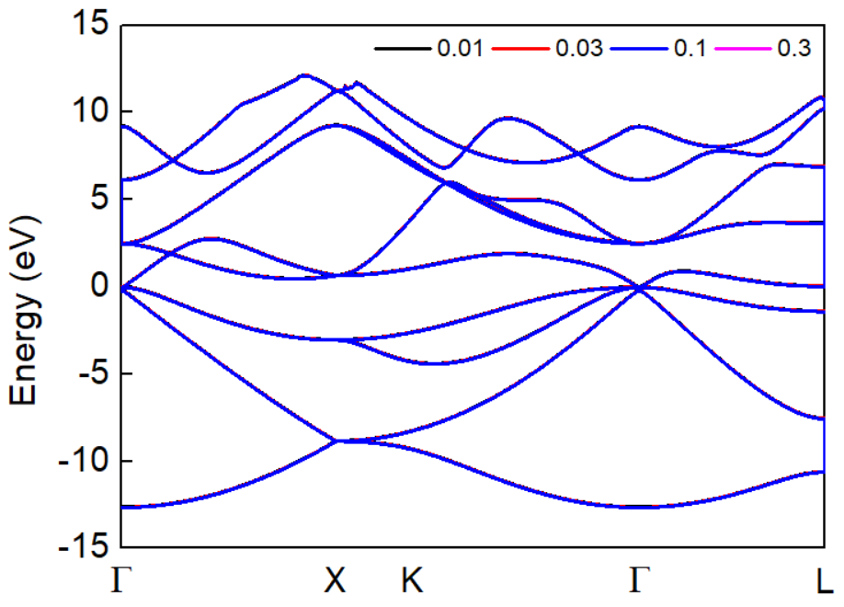

Fig 4. Band structures computed with different SIGMA.

(ENCUT=225eV, ISMEAR=0, DFT k-point grid=14x14x14)

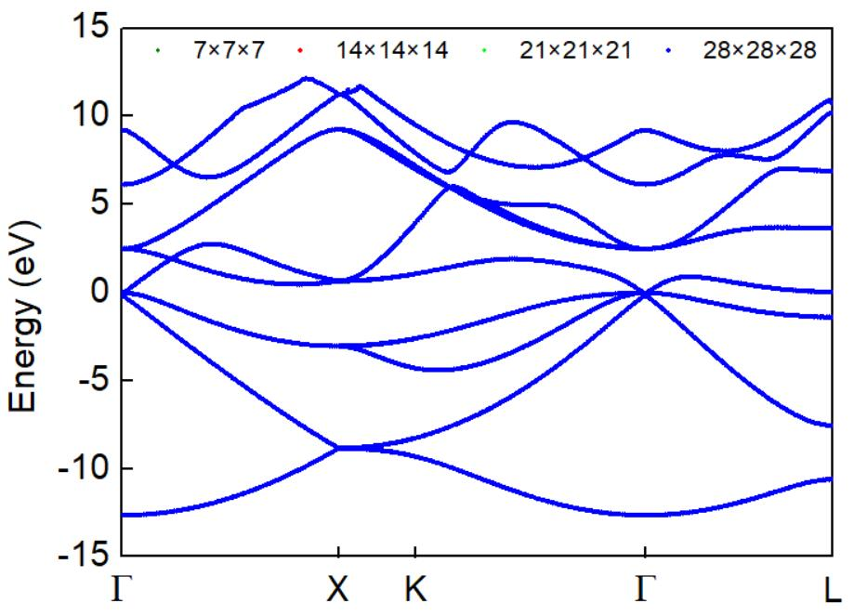

Fig 4. Band structures computed with different DFT k-point grids.

(ENCUT=225eV, ISMEAR=0, SIGMA=0.03eV)

**Based on the above tests, the band structure was calculated with ENCUT=225eV, DFT k-point grid=14x14x14, ISMEAR=0 and SIGMA=0.03eV.**

* Other notes / cpu hours

hardware: Intel Xeon Gold 6150, 18 core/CPU, 2 CPUs/node

5s running with 1 node

* All input files to run fully converged calculations

Input files: INCAR.sc, KPOINTS.sc, INCAR.band, KPOINTS.band, POSCAR, POTCAR, run.sh

Location: Team Shiomi/Han Meng/02_Electrons/Input files

***Harmonic***

* Converged dispersion (target accuracy < 0.1 THz for Γ/X/L frequencies)

- Numerical data: normalized wavevectors (q) and frequencies (f) for 6 polarizations (*j*) (excel or text file)

- q in units of 2π/*a* and f in THz (f=ω/2π)

- 3 segments: Γ→X, Γ→K→X, and Γ→L evenly divided with ~100 q points per segment

- 3 files, one for each segment. For each scaled q from 0 to 1 list (~100 rows): q, f1, f2, f3, f4, f5, f6

File name: G-X.txt, G-K-X.txt, G-L.txt

Location: Team Shiomi/Han Meng/03_Harmonic/Results

* Converged harmonic interatomic force constants (IFCs)

- Standard format for code used (*e.g.*, QE, Phonopy)

- Will be supplied as supplemental material upon publication

File name: Ge222_harmonic.xml

Location: Team Shiomi/Han Meng/03_Harmonic/Results

* Methods / convergence criteria

- Thresholds

EDIFF=1E-8

- Supercell size / integration mesh

Supercell size=2x2x2 conventional cell, DFT k-point grid=10x10x10

- Symmetries / irreducibility / number of calculations (*linked to cpu hours below*)

Symmetry operations=1536, irreducibility=26 IFCs, number of calculation=1

- Post-processing (*e.g., enforce invariance constraints*)

ALAMODE: ICONST = 1, Constraints for translational invariance is considered

* Evidence of converged dispersion

- Dispersions with varying supercell sizes and integration meshes

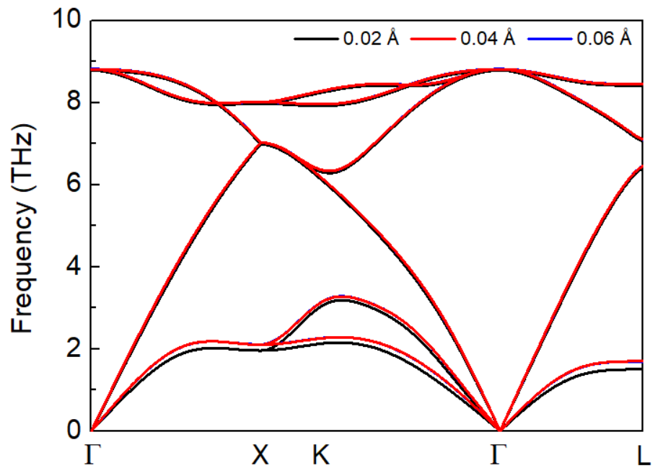

Fig 5. Dispersions computed with different displacements.

(2x2x2 conventional cell, ENCUT=225eV, ISMEAR=0, SIGMA=0.03eV, DFT k-point grid=10x10x10)

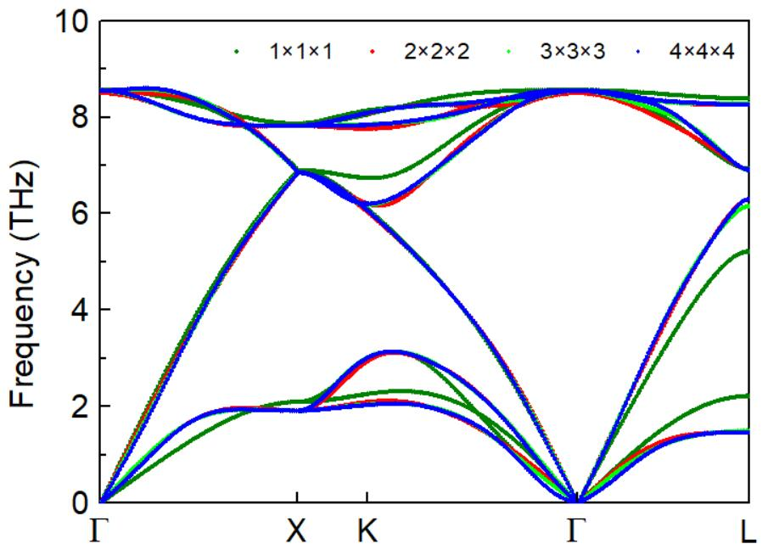

Fig 6. Dispersions computed with different supercells.

(displacement=0.04Å, ENCUT=225eV, ISMEAR=0, SIGMA=0.03eV, DFT k-point grid=20x20x20 as of conventional cell)

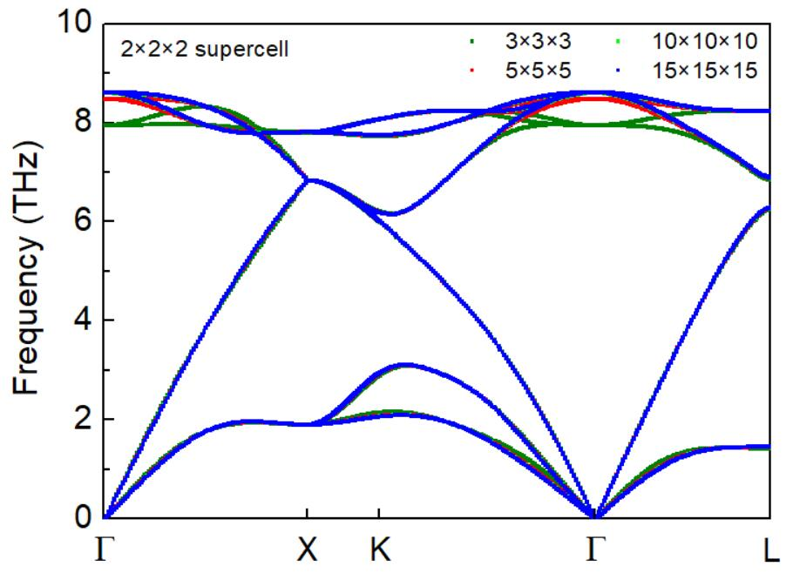

Fig 7. Dispersions computed with different DFT k-point grids.

(2x2x2 conventional cell, displacement=0.04Å, ENCUT=225eV, ISMEAR=0, SIGMA=0.03eV)

**Based on the above tests, the phonon dispersion was calculated with displacement=0.04**Å**, 2x2x2 conventional cell, ENCUT=225eV, ISMEAR=0, SIGMA=0.03eV, DFT k-point grid=10x10x10.**

* Other notes / cpu hours (*e.g., accuracy vs cpu cost, shifted meshes*)

hardware: Intel Xeon Gold 6150, 18 core/CPU, 2 CPUs/node

12min running with 1 node

shift mesh: 0 0 0

* All input files to run fully converged calculations

Input files: Ge_alm1.in1, Ge_alm1.in2, Ge_band.in, Ge222.opt, INCAR, POTCAR, KPOINTS, run.sh

Location: Team Shiomi/Han Meng/03_Harmonic/Input files

***Anharmonic thermal transport***

* Four converged T-dependent thermal conductivities (*k*): natural isotopes with full BTE solution (*knat,full*), natural isotopes with the relaxation time approximation (RTA) (*knat,RTA*), isotopically pure (100% 70Ge (69.924 amu)) with full BTE solution (*kpure,full*), and isotopically pure with RTA (*kpure,RTA*). If only RTA available, then only *knat,RTA* and *kpure,RTA*

- Do not include boundary scattering, even at low T. We want to see how the codes behave at low T without this extrinsic scattering.

- Numerical data: T (K) and *k* (W/m/K) in range 10K < T < 1000K (excel or text file)

- For 10K ≤ T ≤ 50K increments of 10K (5 data points); for 50K < T ≤ 300K increments of 25K (10 data points); for 300K < T ≤ 1000K increments of 100K (7 data points).

- 1 file with T from 10K to 1000K list (22 rows): T, *knat,full*, *knat,RTA*, *kpure,full*, *kpure,RTA*

File name: TC_temperature.txt

Location: Team Shiomi/Han Meng/04_Anharmonic/Results

* Accumulated T=300K *kacc* vs frequency and *kacc* vs mean free path (mfp) for converged *knat,RTA* value

- Numerical data for each mode (q, *j*) sampled in the Brillouin zone integration: f (THz), mfp=|sqrt(*vx*2+*vy*2+*vz*2)×lifetime| (nm), mode contribution to *k* (W/m/K) for *knat,RTA*

- 1 file (excel or text) with row for each mode (q, *j*): f, mfp, mode contribution to *k*

File name: Accumulated TC_nat_RTA_300K.txt

Location: Team Shiomi/Han Meng/04_Anharmonic/Results

* RTA T=300K three-phonon scattering rates (1/*τ3ph*) and phonon-isotope scattering rates for natural abundance (1/*τiso*)

- Numerical data: f (THz), 1/*τ3ph* (THz=1/ps), and 1/*τiso* (THz)

- 1 file (excel or text) with row for each mode (q, j): f, 1/*τ3ph*, 1/*τiso*

File name: Scattering rate_nat_RTA_300K.txt

Location: Team Shiomi/Han Meng/04_Anharmonic/Results

* Converged third-order anharmonic IFCs

- Standard format for code used

- Will be supplied as supplemental material upon publication

File name: Ge222_cubic.xml

Location: Team Shiomi/Han Meng/04_Anharmonic/Results

* Methods / convergence criteria: thermal conductivity

- Delta function representation (*with details; e.g., adaptive smearing, cutoff*)

ISMEAR = -1 Tetrahedron method

- Integration grid: RTA q-grid=50x50x50

- Symmetries used: 48 symmetry operations

* Methods / convergence criteria: anharmonic IFCs

- Cutoff radius, supercell size, integration mesh, thresholds, displacement parameter for supercell derivatives

Cutoff=10 Bohr, supercell=2x2x2 conventional cell, DFT k-point grid=5x5x5, EDIFF=1E-08, displacement=0.06Å

- Post-processing

* Evidence of converged *k* at T=300K

- Varying integration meshes

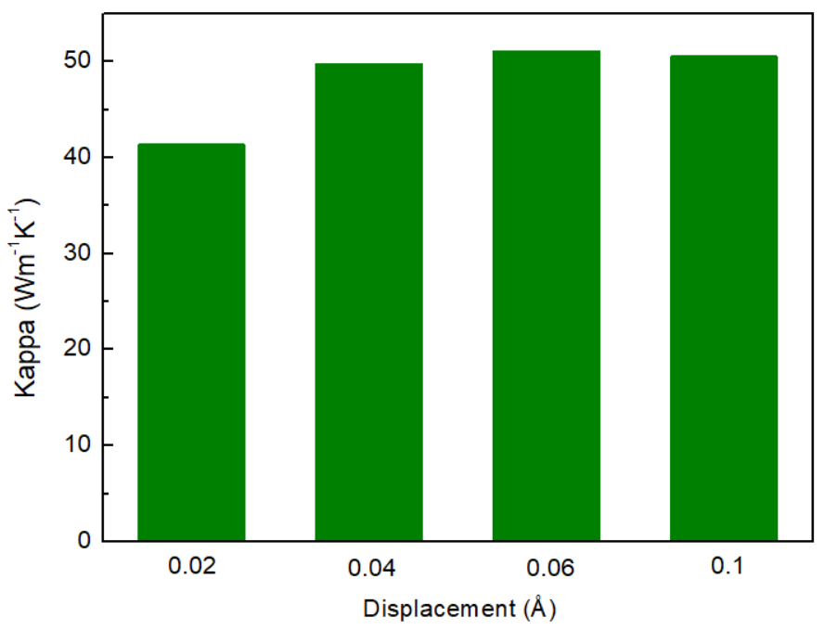

Fig 8. *kpure,RTA* at 300 K computed with different displacement.

(Cutoff=10 Bohr, DFT k-point grid=5x5x5, RTA q-grid=20x20x20)

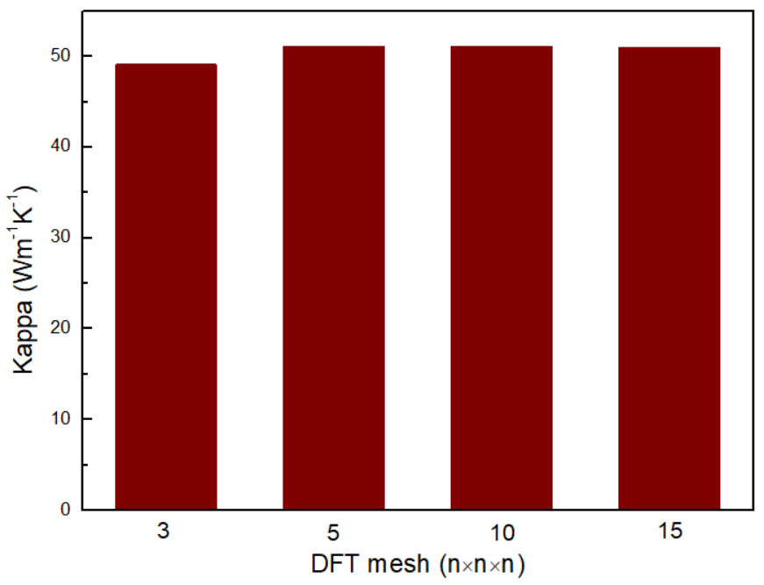

Fig 9. *kpure,RTA* at 300 K computed with different DFT k-point grid.

(Cutoff=10 Bohr ,displacement=0.06Å, RTA q-grid=20x20x20)

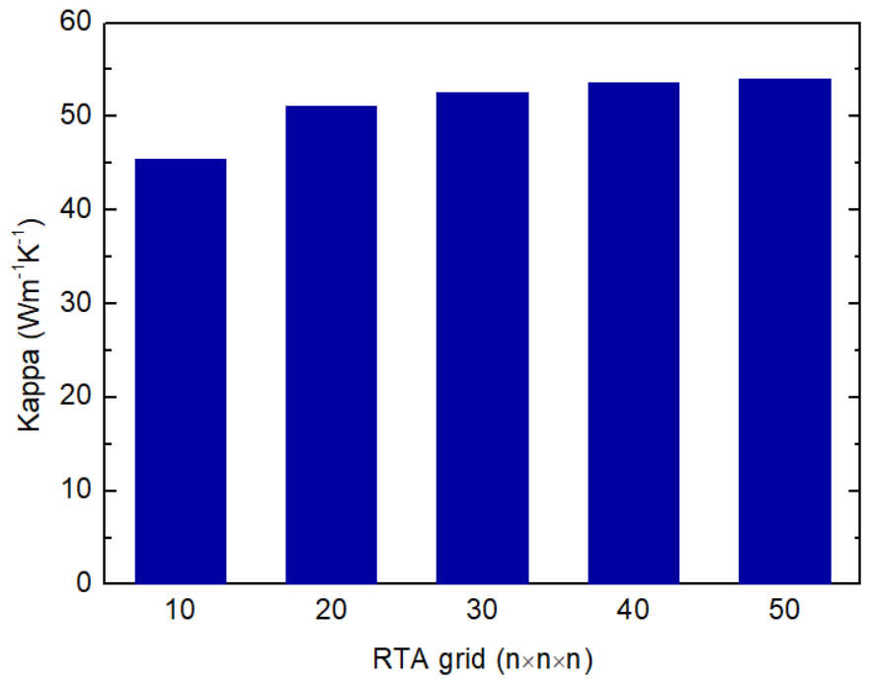

Fig 10. *kpure,RTA* at 300 K computed with different RTA q-grids.

(Cutoff=10 Bohr, displacement=0.06Å, DFT k-point grid=5x5x5)

**Based on the above tests, the thermal conductivity was calculated with 2x2x2 conventional cell, displacement=0.06Å, DFT k-point grid=5x5x5, RTA q-grid=50x50x50.**

* Other notes / cpu hours

hardware: Intel Xeon Gold 6150, 18 core/CPU, 2 CPUs/node

50h27min running with 1 node

* All input files to run fully converged calculations

File name: Ge_alm2.in1, Ge_alm2.in2, Ge222.opt, INCAR, POTCAR, KPOINTS, Ge_RTA_nat.in1, Ge_RTA_pure.in1, run1.sh, run2.sh

Location: Team Shiomi/Han Meng/04_Anharmonic/Input files